Clusters meet Regions

Clusters as key drivers of regional development and growth

Andalusia / Spain
The pilot edition of the new ECCP series of events “Clusters meet regions”
In the frame of the Foro Transfiere, 16 – 17 February 2022, Malaga Spain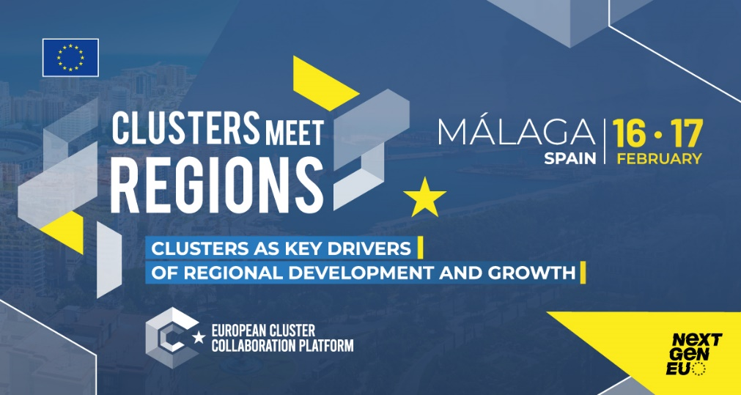

Clusters meet Regions – context and objectives
EU regions need to be able to compete with other more advanced and emerging economies in the fast changing economic and social environment, in particular in the post-Covid-19 recovery period. Location matters particularly for clusters. They develop more easily in urban and regional ecosystems with a favourable administrative and regulatory environment and access to skilled labour, markets, financial and business support services.
What really matters is the involvement of clusters in regional economic governance, in policy design and implementation at regional level.
Regional authorities need to know their clusters and understand how they can shape, improve and effectively help in the design and the implementation of the regional development policies. Cluster organisations and their members should take actions and implement projects that are relevant for the economic development of their local communities. They should engage in collaboration with other European clusters in the same or related economic activities and thus complement regional assets and reinforce capacities to lead green transition, accelerate digital transition and build resilience.
15 regional workshops will be organised in the EU regions, which express their interest to host the events in 2022-23 as part of the “Clusters meet Regions” cycle. These workshops will bring together clusters and policymakers of the EU, national, regional and local level to learn from each other how to better use clusters to strengthen industrial ecosystems, serve national/regional economic development and liaise with other regions with similar transition challenges.
The “Clusters meet Regions” in Malaga is the first one of the series and is considered to test the organisation, format and topics so that the next 14 workshops are helpful for cluster managers and policy makers resulting in the engagement of clusters in the regional priorities. The current workshop will be structured in line with the priorities established by the region of Andalusia and the European Industrial Strategy as updated in May 2021.

Agenda
16th February 2022
11h00 – 12h00  (Main Hall) | Ceremony of Opening the Forum  Foro Transfiere (fycma.com)  For over a decade, the forum gathers overs 3,000 professionals. It is the biggest professional and multi-sectoral Forum for knowledge and technology transfer that takes place in Spain, and that gathers the most relevant players in the national and international R&I ecosystem. It has the confirmed participation of the Spanish Minister of Science and Innovation and the Regional Minister of Andalusia.  This year, the 11th edition, Foro Transfiere’s programme of thematic panels and conferences is divided into 6 different spaces where attendees have the opportunity to discuss the latest information about internationalization opportunities, AI (Artificial Intelligence), digital transformation, 4.0 industry, open research and innovation, and public procurement of innovative solutions, among many other topics
12h00 – 12h45  (room 1)  English | Clusters as key drivers of regional development and growth  Moderator: Esteban Pelayo. European Association of Development Agencies. EURADA (confirmed)  The opening of the workshop: Cluster meets Regions shows the involvement of clusters in regional economic governance, in policy design and implementation at regional. To do so, the conference starts explaining the EU clusters policies and priorities from Andalusia.  - Regional priorities and S4 Andalusia  Pablo Cortés Achedad. Secretary General for Enterprise, Innovation and Entrepreneurship. Regional Government of Andalusia  - Cluster policy in Spain  Jordi Llinares – General Directorate for Industry and SMEs in Spain  - EU industrial and cluster policy  Ulla Engelmann – HoU Networks, Clusters DG GROW European Commission
12h45 – 13h30  (room 1)  English | Setting the Scene  - Introduction and objectives of Clusters meet Regions workshops  Marek Przeor. DG GROW. European Commission  - Input paper for the Clusters meet Regions workshop  Dr. Jan-Philipp Kramer Prognos
13h30 – 14h30 | Networking lunch
14h30 – 16h00  (room 1)  English | Priority areas and industrial ecosystems in Andalusia  Moderator: Teodora Jilkova. Cluster Veritas  Relevant priorities in Andalusia are defined in their specialisation frameworks of the S4 Smart, Resilient, Healthy and Industrial Society (E1), Agrotechnology (E2), Natural Resources: Mining and Water Cycle (E3), Mobility and Logistics (E4) and Energy Transition (E5). Cluster managers and regional experts from Andalusia will discuss how to carry out green, digital transition and build resilience in their specific ecosystems. The session aims to highlight good practices of cluster engagement in regional economic development and identify areas where clusters can provide support.  - Regional policy  Representative of Unit Spain. DG Regio. European Commission  - Development on social welfare  Rafael Padura. Digital Economy OnTech Innovation  - Experiences to support digitalisation and industrial policies  Ola Svedin. Mobile Heights. Clusters of Sweden  - Experiences on energy cooperation  Joaquin Villar. Energy Agency of Andalusia  - MASDE: involvement of clusters in projects promotion and evaluation  Carmen Marcos. Development Agency of the Region of Valencia. IVACE
16h00 – 16h30 | Coffee break

16h30 – 18h00  (room 1)  English | Cluster driven interregional collaboration in the framework of the priorities of Andalusia  Moderator: Eva Revilla. European Commission  Linkages with clusters from other regions to cooperate require identification of partners and building common ground for collaboration. Experiences from other regions will be shared, information on S3P and clusters partnerships as well as search for collaboration areas.  - Thematic Smart Specialisation Platform  Karel Haegeman. JRC European Commission  - Cluster-region cooperation on Agrotechnology and innovation  Kristina Sermuksnyte-Alesiuniene. AgriFood Lithuania  - Traceability & Big Data partnership  Mar Catedra. Regional Ministry of Agriculture of Andalusia (tbc)  - S3P Digitalisation and Safety for Tourism  Ana Moniche, Public Entity for Tourism and Sport Management in Andalusia, S.A.S  - Cooperation with clusters in Basque country for the transition pathways  Cristina Oyón, Development agency from Basque Country. SPRI. Vanguard Initiative  - Opportunities of cooperation in smart cities  Daniel González. Smart City Cluster
Plenary session
18h20 – 19h00  (Main Hall)  English | Clusters meet Regions: How to make the workshop useful for cluster managers and policy makers  Moderator: Antonio Novo. ECAS (confirmed)  In an open debate format, participants will discuss how should the workshop be organised, what kind of format used, what topics to be raised, who should be involved as participants and speakers so that Cluster meet Regions attracts attention of policy makers and cluster managers (companies)  - Nuria Villén. Regional Development of Andalusia. Agencia Idea  - Krzysztof Krystowski. European Cluster Alliance (ECA)  - Roberta Dall’Olio. ART-ER Regional Development Agency Emilia-Romagna. President of EURADA  - Werner Pamminger. Business Upper Austria
19h00 – 20h00  Hall 1  Spanish | Meeting between Spanish national and regional public authorities and Spanish clusters  (in Spanish, on invitation only)

17th February 2022
10h00-11h00  (room 1)  English |  | Pitching session: Cooperation proposals forum (Part I)  Moderator: Nuria Villén. CESEAND-EEN. Development Agency of the Region of Andalusia. Agencia IDEA (confirmed)  The Cluster meets Regions organization provides a space for the clusters and regions to presents themselves, their collaboration proposals and increase their network partners. The participation as a panellist in this part of the conference is open to any assistant to the event by previous registration as a panellist to pitch.  - Mobility and Logistics  - Digitalisation Trazability & Tourism
11h00 – 11h30 | Coffee break
11h30 – 12h30  (room 1)  English | Pitching session: Cooperation proposals forum (Part II)  Moderator: Lucia Díaz CESEAND-EEN. Agency of Knowledge. Government of Andalusia (confirmed)  Continuation of the presentations of profiles and proposals of cooperation during the Cluster meets Regions conference in the following topics:  - Energy transition  - Health and Social Welfare
13h00 – 14h00 | Networking lunch
14h00 – 18h00  English | Site visits  Malaga is a leading city in innovation and smart city terms. The participants will have the opportunity to visit the local actors who play a leading role in the ecosystem. There will be two different itineraries: one in digitalisation (agrotechnology, smart cities and tourism) and the other one related to energy, logistics and transport  - Digitalisation route: Andalusia Technology Park, DEKRA company (Test circuit autonomous vehicles), and Digital Pole (Business incubator of the Municipality of Malaga)  - Route for energy, logistics and transport: Andalusia Technology Park, TORSA company (Mining, Logistics and Renewable Energies), and The Green Ray (Business incubator of the University of Malaga)

